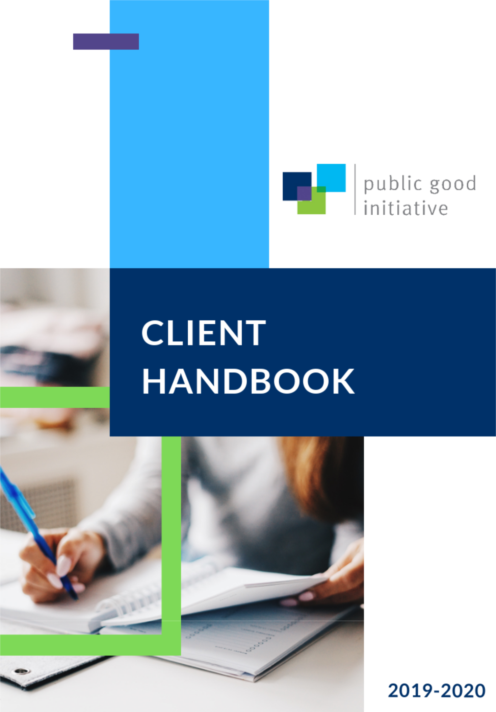
2023-2024
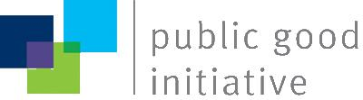
Directors’ Message:

Thank you for your interest in partnering with the Public Good Initiative (PGI). We are a student-led, pro bono consulting organization at the University of Toronto’s Munk School of Global Affairs and Public Policy. PGI matches student consultants with community organizations looking to benefit from our policy-based consulting services. We offer our clients the specialized skills and abilities of policy students to analyze, design, and execute projects, while our students gain hands-on policy consulting experience.

PGI has partnered with more than 80 organizations since its inception in 2008. Clients continue to be satisfied with their consultant teams and have described them as hardworking, committed, professional, and highly adaptive. During the past academic year, PGI partnered with thirteen organizations on projects that varied in size and policy capacity including the AGE-WELL, the Algoma Community Foundation, the Canadian Urban Institute, CNIB, and the Samara Centre for Democracy, among others.

Our consultants are creative and independent problem-solvers with strong analytical and critical thinking skills. Building on the foundations of the Master of Public Policy and Master of Global Affairs programs at the Munk School of Global Affairs and Public Policy, our consultants bring great value to policy work and discussion.

As the directors of PGI, we strongly believe that our consultants are of the highest caliber and will make a positive contribution to your organization.

If you are interested in having our consultants work with you on a project, please complete and submit the Project Scope Client Application Form by August 26, 2023, and email to publicgoodinitiative@gmail.com.

Best Regards,

Christina Winger (Director, Client Relations)

Dechen Tenzin (Director, Client Relations)

Albina Magomedova (Director, Internal Relations)

Yassmen Araim (Director, Internal Relations)
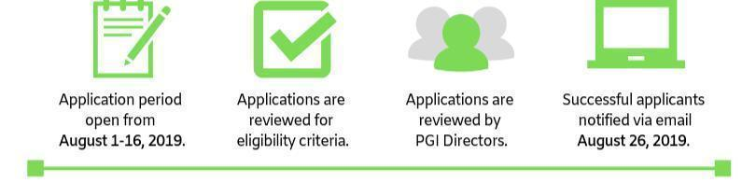

Applications open:
July 24, 2023
Deadline to submit applications:
August 26, 2023
Applications are reviewed by PGI Directors
Successful applicants will be notified:
September 8, 2023

Completed applications should be submitted via email to

publicgoodinitiative@gmail.com.
What is PGI?

PGI recognizes that our Master of Public Policy and Master of Global Affairs consultants have valuable skills and unique insights to contribute toward the public good. PGI consultants are carefully selected through a competitive application process open to first and second year Munk School of Global Affairs and Public Policy students. Our consultants have access to the wealth of knowledge and expertise possessed by Munk’s staff, faculty, and fellows for guidance and support. PGI is fortunate to have a strong team of policy and consulting professionals who serve on our Board of Advisors to provide advice on matters of governance, best practices, and long-term strategy.
Our consulting services are provided on a pro-bono basis, ensuring that all organizations can benefit from the extensive abilities and diverse set of perspectives our consultants bring to their projects. PGI recognizes the importance of relationships in the policy and non-profit sector. The work we do represents an exciting opportunity for growth and innovation for both our organization and the overall sector.

Our Mission:

The Public Good Initiative strives to strengthen the policy capacity of the non-profit sector. By drawing on the skills and experience of our consultants, we as an organization seek to meaningfully engage with our partners and positively contribute to the public good.

Past Clients Include:

4Rs Youth Movement People for Education

Age-Well Peel Newcomer Strategy Group

Canadian Urban Institute Samara Centre for Democracy

Centre for Social Innovation Sistering

Cumming School of Medicine Canada Schools Without Borders

David Suzuki Foundation Sierra Youth Coalition

Friends of the Greenbelt Foundation Time to Talk

Girls E-Mentorship Toronto Arts Foundation

Houselink Community Homes Toronto Drop-In Network

IMAGINE Clinic University Health Network

Mid-Toronto Community Services University Settlement

Mid-West Toronto Health Link WoodGreen Community Service

Ontario Nonprofit Network Young Women’s Leadership Network

Ontario Association of Interval & Transition Houses

Peacebuilders Canada

Summaries of past projects can be found online.

Please visit the 2022-23 Projects page on our website.

What do PGI Consulting Projects look like?

Projects will be shaped around the needs of the client organization, the skills and backgrounds of the consultants, and the timelines and resources available.

Fully assessing these from the outset of the consultant process will allow us to maximize the benefits that PGI can provide to your organization.

Our consultants are trained for work in the public, private, and not-for-profit sectors relating to:

- Policy-making and analysis
- Problem-solving, strategic planning and advocacy
- Statistical data collection and analysis
- Consultations with stakeholders or citizen groups
- Social policy
- Non-profit governance
- Researching and preparing policy materials
- Decision-making in government, and beyond...

What can clients expect?

- Consulting services provided by a team of 3 or 4 Masters of Public Policy and students from the Munk School of Global Affairs and Public Policy at the University of Toronto;
- Up to 3 hours of focus per week from our consultants for approximately 6 months of total project time;
- A negotiated agreement clearly defining project scope, deadlines, meeting schedules, and other elements of the partnership; and
- High-quality deliverables from our consultants that meet expectations outlined in the client-consultant agreement.

Client Responsibilities:

- Maintaining communication with consultants throughout the duration of the project, including providing consultants with feedback on a regular basis
- Proposing a project idea with very clearly defined deliverables, timelines, and a list of available resources for the consultants
- Briefing consultants about the project scope and objectives, and providing background materials that describe the organization’s mission, structure, ongoing initiatives, etc.
- Covering any major project-related expenses (purchase of data, printing, etc.)
- Completing evaluative surveys during and after the completion of the project
- Making an effort to accommodate consultants in regard to their other academic or extracurricular commitments during the year, if possible

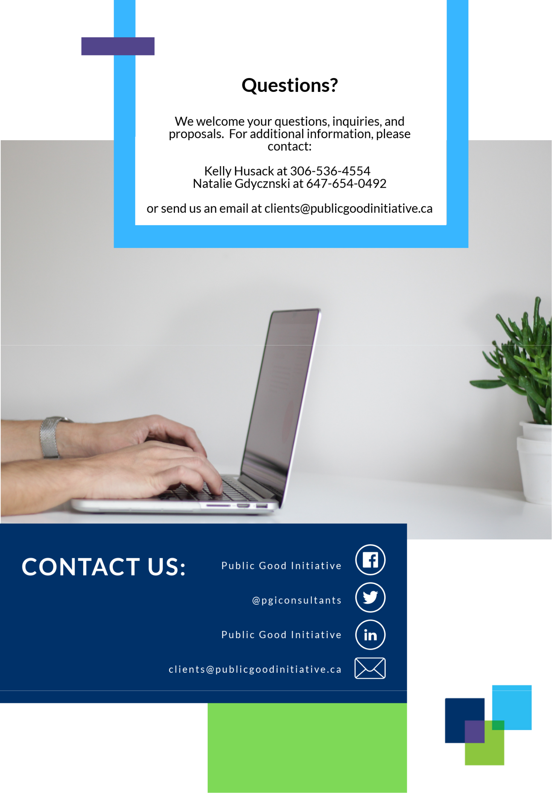
Questions?

We welcome your questions, inquires, and proposals. For additional information contact:

Christina Winger at (519) 614-4520
Dechin Tenzin at (416) 553-9823

Or send us an email at publicgoodinitiative@gmail.com
publicgoodinitiative@gmail.com

